**EXPENSE TRACKER**

The Database, table and fields as they appear with id as the primary key.

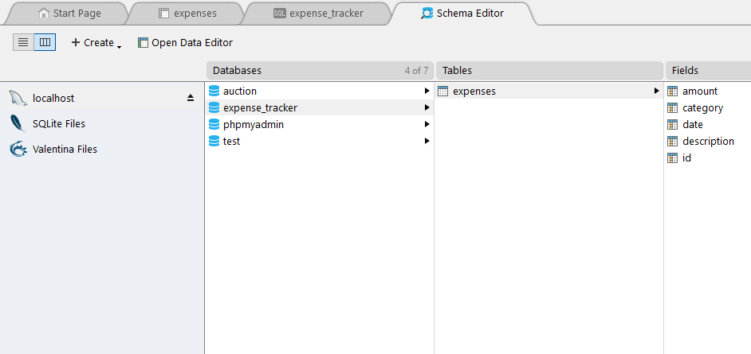

Running the sql query to insert record/data into the tables.

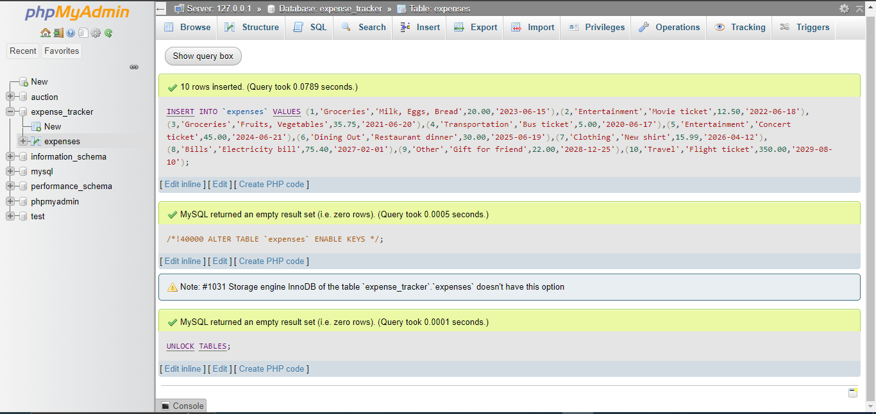

The data as it appears on the database

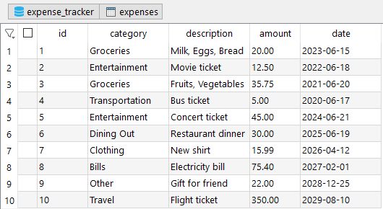

**Grouping Expenses by Category and Counting**

To find out how many expenses you have in each category, you use **GROUP BY** along with **COUNT**

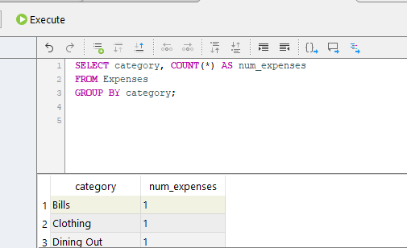

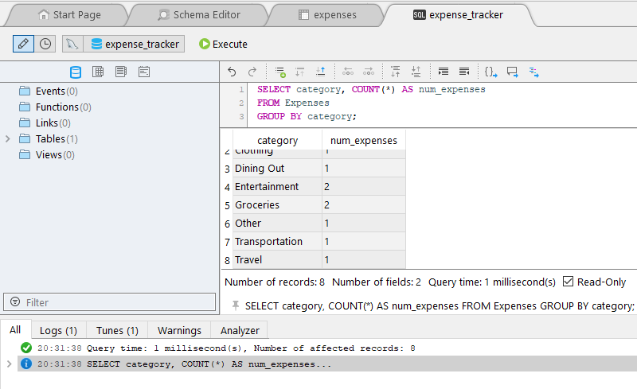

**Total Expenses for Each Category**

To calculate the total amount spent in each category, you use **SUM**. Here, total spent will show the sum of amount for each category, giving you the total expenses in that category.

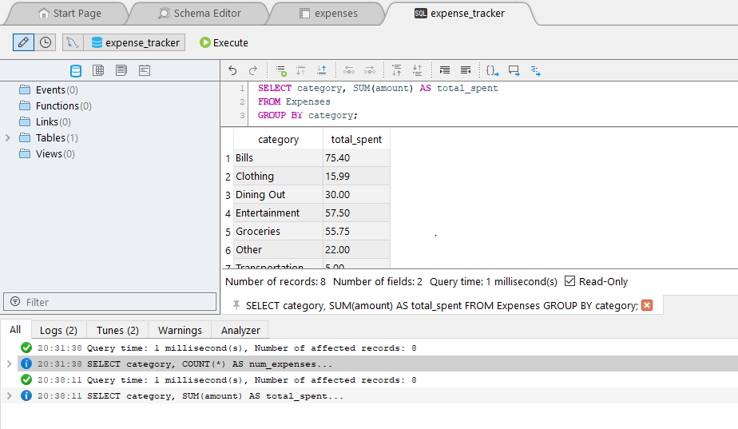

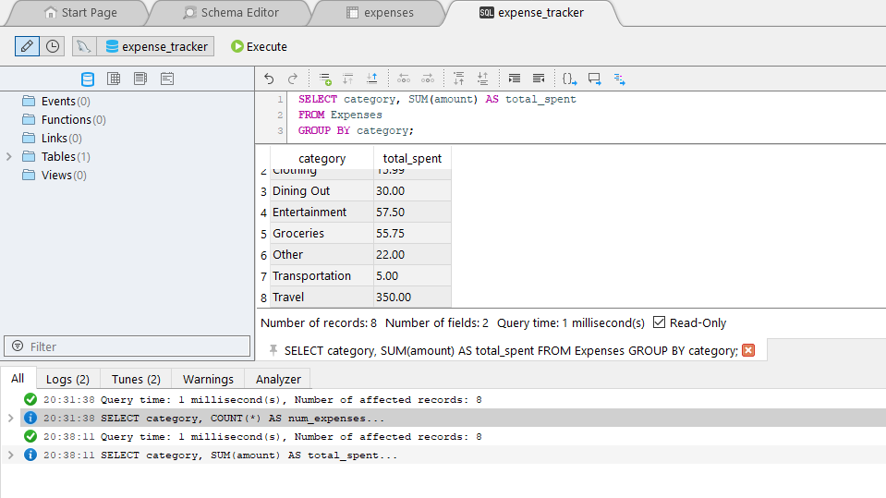

**Average Expense Amount for Each Category**

To find the average expense amount for each category, you use **AVG**. This query calculates the average of the amount column for each category.

